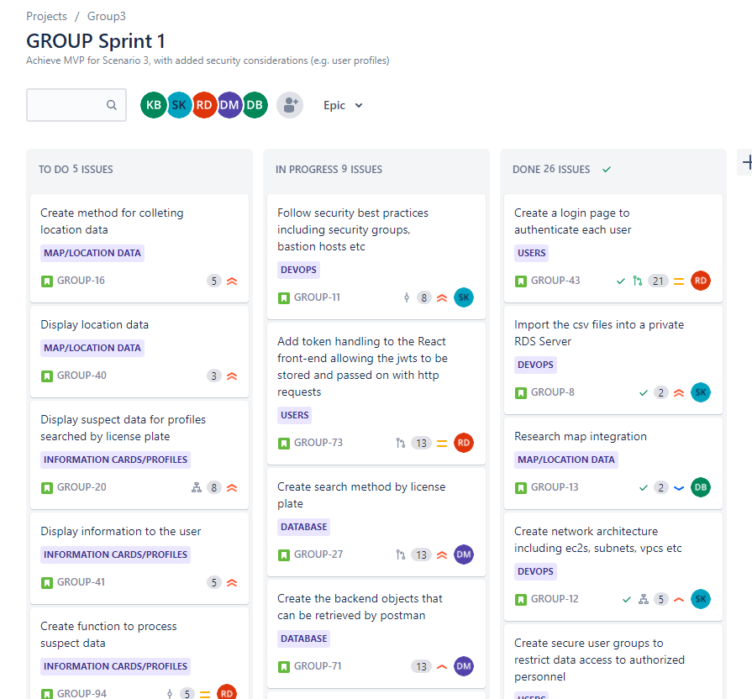
1.SPRINT

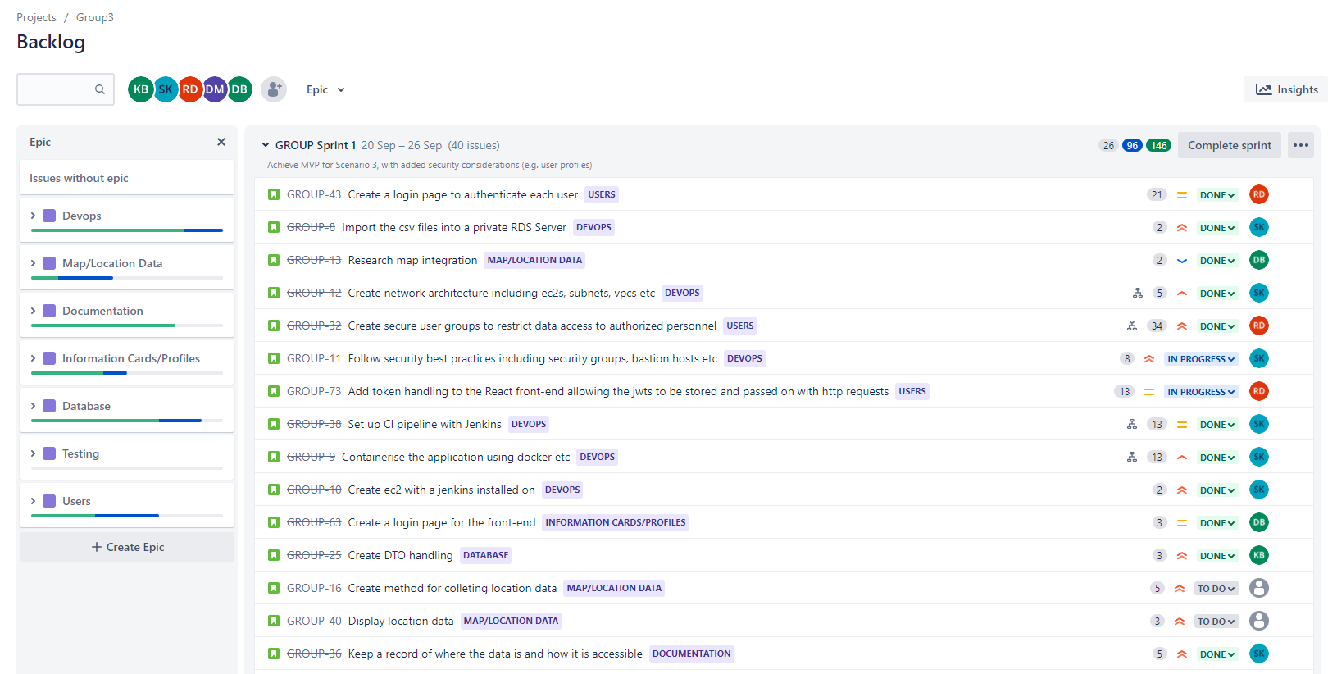
2.EPICS, ISSUES

3.SPRINT BURN DOWN CHART
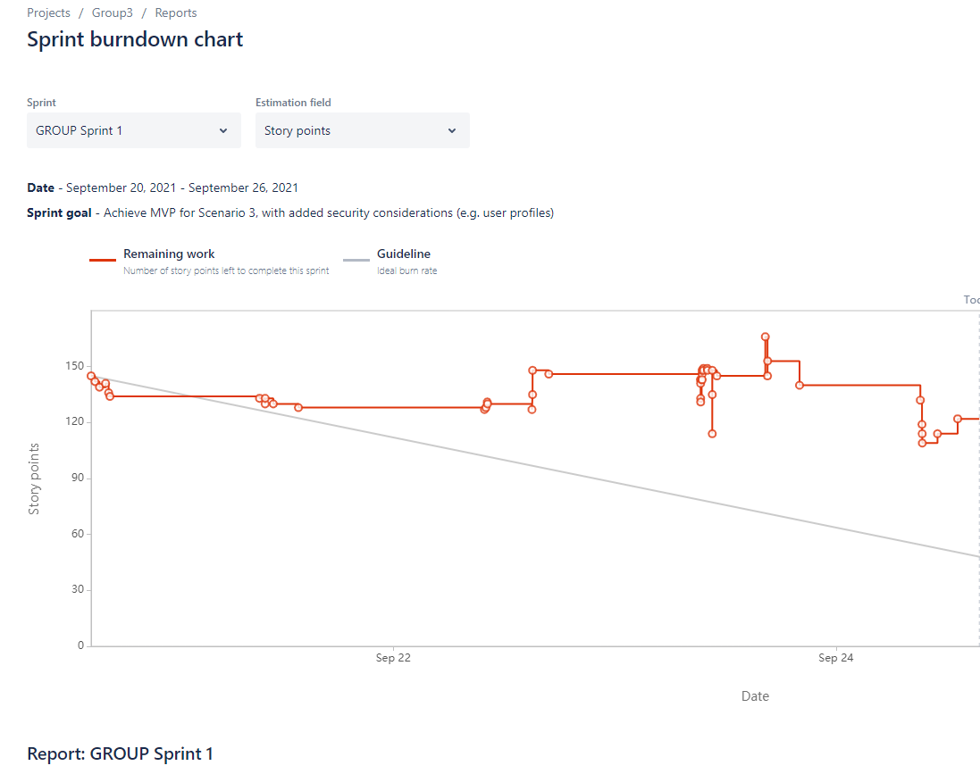

4.smart commits
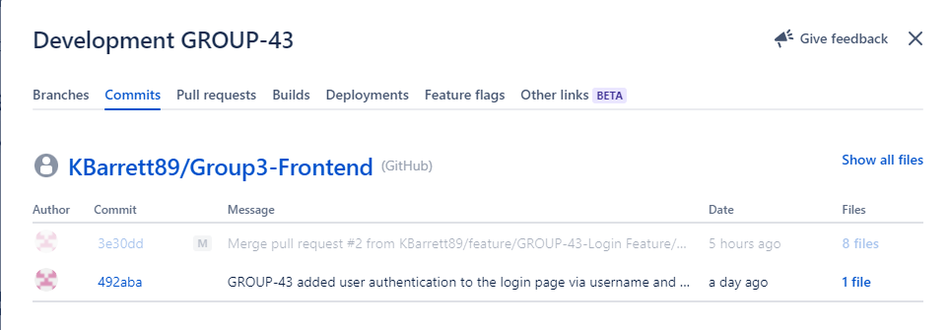

5,6,7.Network graph - Backend
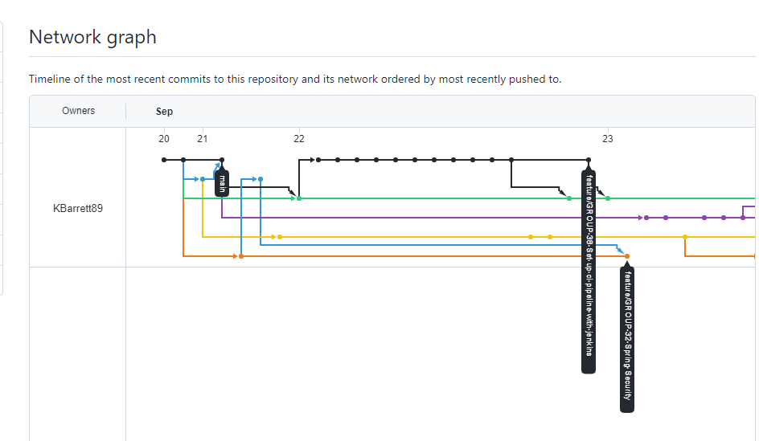
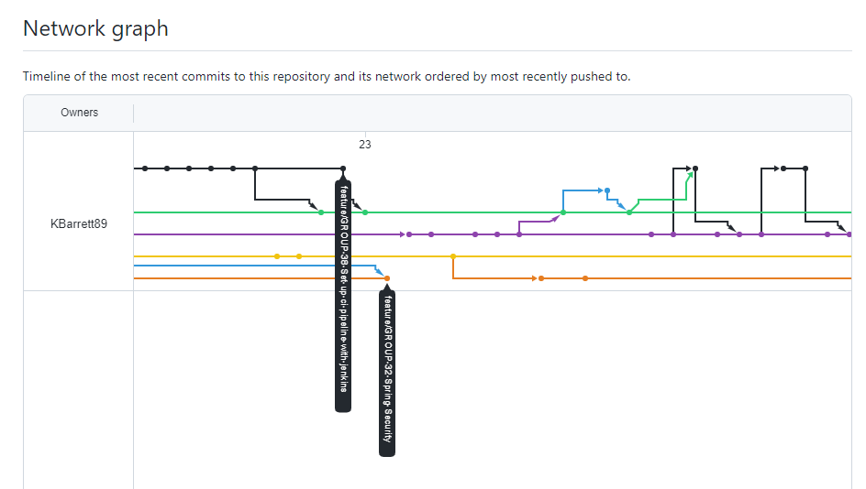
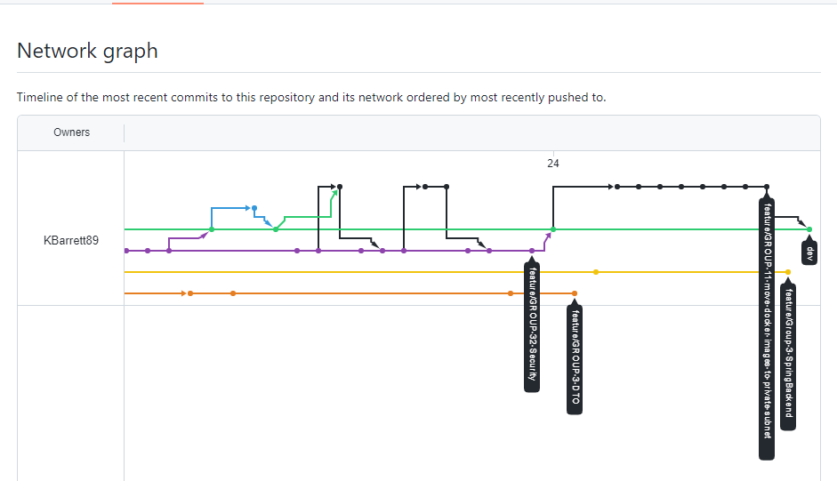

8.Network graph – Frontend


